Introduction:
This project explores the development of a full taxi booking system using the Python programming language, encapsulating the essence of mathematics and concepts for computational thinking. This assignment asks individuals or groups to design a program that enables customer booking review, removal options, route bookings with driver selection, client registration, login functionalities, and seamless integration with a SQLite or MySQL database. The program must be created using the knowledge gained from the lessons and resources offered at BREO. This project's main goal is to create and put into place a user-centric taxi booking system that facilitates a seamless and effective user experience. The system is designed to offer features including driver selection for routes, customer booking administration, database connectivity, user registration, and login/logout capabilities for reliable storing and retrieving of information.
The application is intended to provide a text-based user interface, guaranteeing usability while preserving necessary features for user account and booking management. A thorough report that goes with the programme will also provide an overview of important elements, including usability, non-functional requirements, and functional needs. In addition, it will include entity connections, UML case diagrams, a data dictionary that clarifies the database structure, a thorough test system, design considerations, implementation techniques, and a perceptive discussion and conclusion part.
Task description:
The current project entails building a taxi booking system using Python and writing an extensive report that describes the system's features and architecture. The application, called the "Taxi Booking System," is intended to make it easier for users to register, log in and out, book routes with a choice of drivers, view, and remove reservations. Additionally, the system has to be able to establish a connection with a SQLite database in order to store user-supplied data, such as travel logs and personal information. The complete programme will be written in text and will be executed as a standalone Python project.

Task No. | Task Description | Priority | Start date | End date
1 | Creating a Program | must
2 | Write report for a program | must
3 | Create/record a mp3 that present hoe program works | must
4 | Check report, program and all things related to assessment | must

Functional requirements
Customer
an opportunity to set up a taxi booking system account for them, including providing all the necessary information if they don't already have one (MUST).
a choice to return or access their TBS accounts (MUST)
a switch to a different account option (MUST)
a view-all-booked travel option (MUST)
a way to revoke unneeded travel (MUST)
a choice to travel (MUST)

Driver
a choice to visit and use their TBS accounts (MUST).
a view-all-booked travel option (MUST)
a choice to remove any unnecessary drives (MUST)
a choice to view all details regarding their drives (MUST)

Admin
An opportunity to access the admin account and log in and out (MUST)
The ability to view all scheduled trips (MUST)
an option to include and exclude every driver (SHOULD)
a choice to view every consumer and their details (should)

Non- Functional requirements
They are essential to the programme's ability to meet all customer expectations, but it is important to remember that they are not requirements that must be met; rather, they are optional. Nevertheless, the programme will operate much more smoothly and effectively as a result of them, which will benefit user tasks as well.

The programme needs to function on a wide range of gadgets.
The programme should always function without any unforeseen issues.
The programme needs to be easy to use.
The programme must meet all user requirements for security and usability.

Important Features of the Taxi Reservation System:
User Account Creation: Permit users to create accounts on the system. User Login/Logout: Make it safe for users to log in and out. Make it possible for users to reserve routes with the choice of accessible drivers. View and Delete Bookings: Make it possible to see and delete reservations. Database Connectivity: Verify that your data storage is integrated with a SQLite database.
Components of an Extensive Report:
System Design: Give a summary of the architecture and design of the taxi booking system. Specify the capabilities that the system has to provide in terms of functional requirements.
Non-Functional Requirements: List the usability, security, and performance standards for the system. Use case and activity diagrams, which show how a system behaves, are examples of UML diagrams that should be included.
Database Dictionary: Describe the entity relationships and database schema architecture in detail.
Interface Design: Explain the user interface design that uses text to facilitate communication.
Test Plan: Describe the approaches and techniques used in the system testing process.
Implementation: Talk about the strategy and techniques applied throughout the system's creation.
Talk and Wrap-Up: Examine the system's performance, drawbacks, potential improvements, and closing thoughts. The purpose of the report is to offer a thorough record of the design, features, and development process of the taxi booking system. It should include every facet listed above, providing a comprehensive grasp of the system's design factors, user interactions, database architecture, testing procedures, and implementation tactics. The project's results, future directions, and importance in meeting the requirements should all be considered in the report's final part.

sea-level :
A sea-level diagram, often referred to as a context-level diagram, is a high-level illustration that shows how different elements interact within a system. The sea level diagram gives a general overview of the external entities in a taxi booking system and how they interact with the main system components. The interactions between users and the taxi booking system itself are the main subject of this graphic. It presents the external parties—drivers, customer, and administrative staff—as well as their relationships and interfaces with the system.
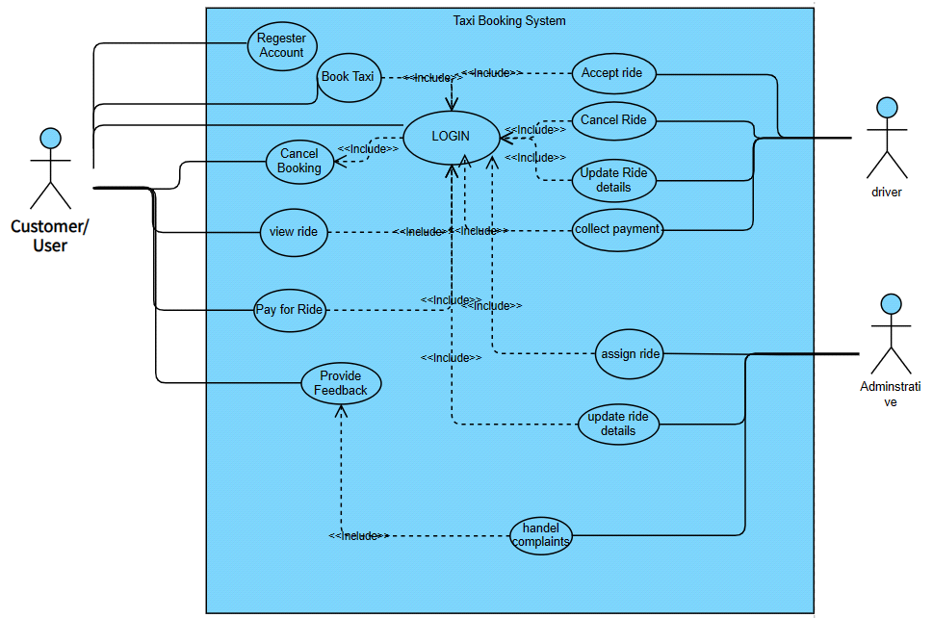
FIGURE 1: Sea Level (Use Case) Diagram
Fish Level:
The functions that customers use in the taxi booking system are the main focus at the Fish Level. Essential information such as title, name, contact information, address, email, password, and payment methods are provided by customers while registering. Customers who have registered may easily book cabs, inspect them, and cancel them by using their Ride ID. Before logging out, clients can further examine their booking 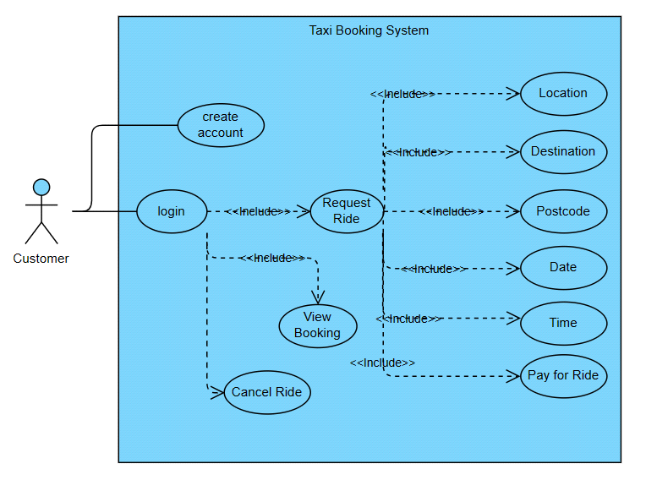history. FIGURE2: Fish Level (Use Case) Diagram
ACTIVITY DIAGRAM:
From the viewpoint of the consumer, the activity diagram shows the orderly sequence of events inside the taxi booking system. It outlines the procedures, which begin with registration and include inputting personal information, authenticating, and creating an account. The booking procedure is then shown, along with choices to see, edit, and peruse booking history. The last step in the graphic, the logout, clearly illustrates a customer-centric interaction process.
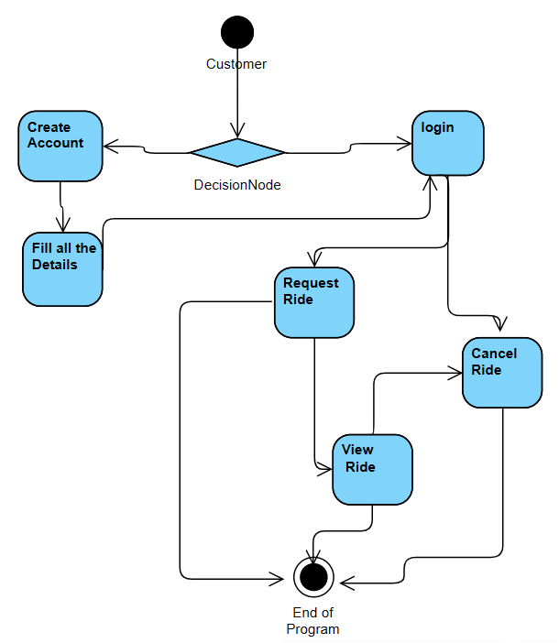
FIGURE 3: Activity Diagram
DATABASE DESIGN:
Customer and Request Ride are the two tables that were made in this SQLite database that are connected to the GUI and include all of the data. Every table has a unique entity in it.
• Customer: (id, username, name, email address, phone number, gender, and password)
• Request for a Ride: (id, customer id, location, destination, postal code, date, time)
For the consumer to access and allocate bookings, they must register their data. Every detail that users enter into the system is kept in the database.
ENTITY RELATIONSHIP MODEL(ERM):
- Customer contains:(id, username, name, email address, phone number, gender, and password)
- Request for a Ride: (id, customer id, location, destination, postal code, date, time)
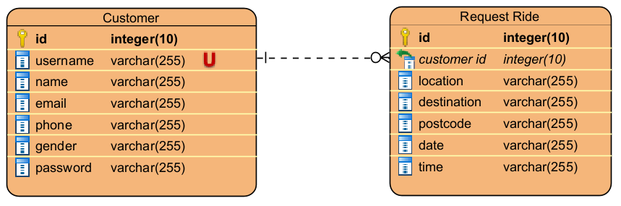
FIGURE4: Entity Relationship Diagram

Entities
Customer (id, username, name, email address, phone number, gender, and password)
Request for a Ride (id, customer id*, location, destination, postal code, date, time)
Primary key = Bold and Underlined
Foreign Key = *
CUSTOMER
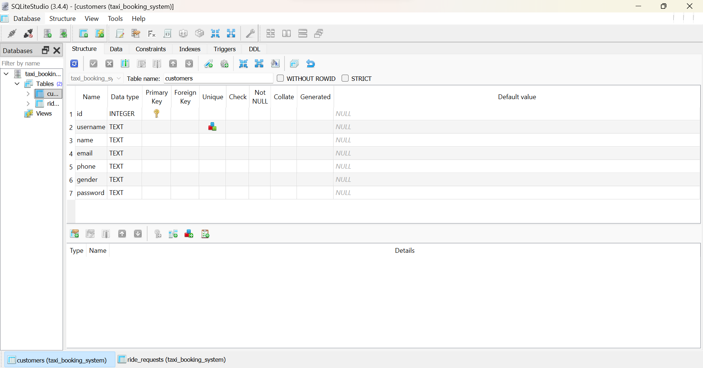
FIGURE5: Customer DATABASE TABLE
REQUEST RIDE
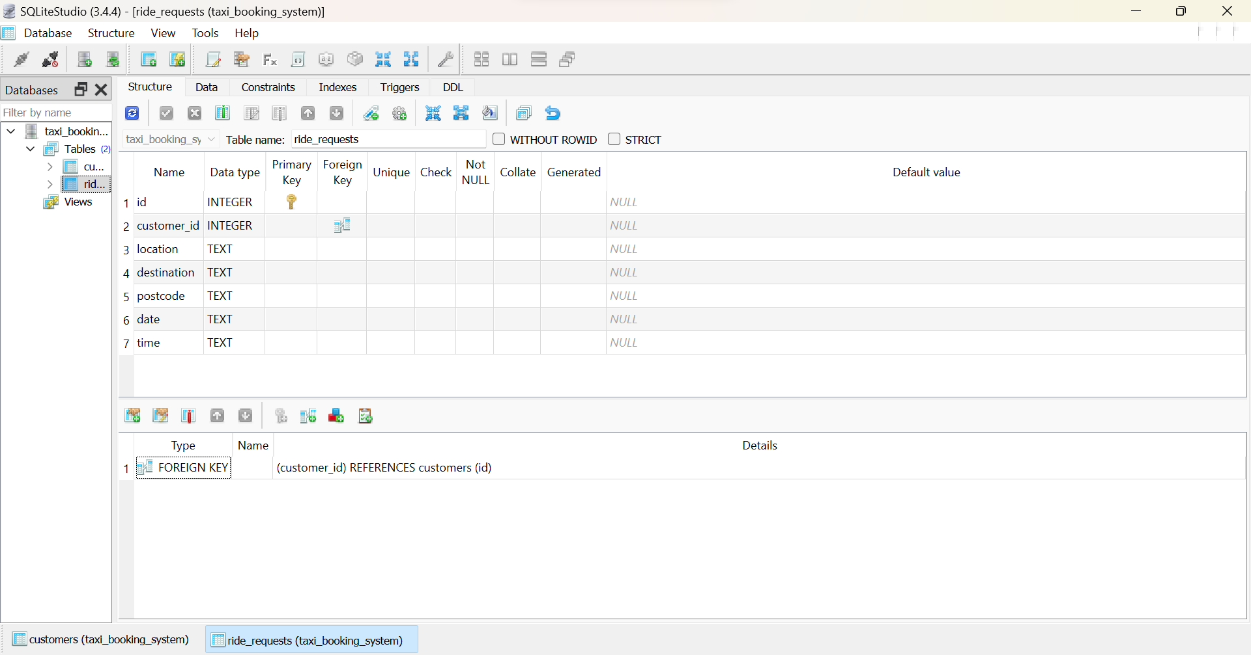
FIGURE6: REQUEST RIDE DATABASE TABLE
Data Dictionary:
The purpose of the data dictionary is to aid users in comprehending the information included in the system. It includes database-related details, including the field name, data type, length, index, null, validation, and description.
Customer
Field Name | Data Type | Length | Index | Null | Validation Rule | Description
ID | Integer (10) | 10 | Pk | no |  | Allows customer to view ride and cancel ride.
username | Text |  |  | yes | Must be valid | Allow customer to login
name | Text |  |  | yes |  | Allow customer to insert their name
email | Text |  |  | yes |  | Customer Email
phone | Text |  |  | yes |  | Customer phone number
gender | Text |  |  | yes |  | Allow customer to choose their gender
password | Text |  |  | yes | Must be valid | Allow customer to login

Request Ride
Field Name | Data Type | Length | Index | Null | Validation Rule | Description
ID | INTEGER (10) | 10 | PK | NO |  | Allows customer to view ride and cancel ride.
Customer id | INTEGER (10) | 10 |  | YES |  | Defines which customer are you
location | TEXT |  |  | YES |  | Allow customer to insert their location
destination | TEXT |  |  | YES |  | Allow customer to insert their destination
postcode | TEXT |  |  | YES | Must be valid | Customer postcode
date | TEXT |  |  | YES |  | Customer Date of travel
time | TEXT |  |  | YES |  | Customers prefer time to travel

User Interface Design:
"How people interact with a device or programme is known as the user interface, or UI. All of the things’ users view and interact with on displays, pages, buttons, and symbols are included. Clarity, usability, and efficiency are the main goals of effective user interface design, which guarantees that users of the technology have a seamless and intuitive experience."

IMPLEMENTATION:
As a beginner in Python application development, I began by using user-friendly IDEs such as Visual Studio Code. These platforms provided powerful capabilities that aided my project setup and package installation, particularly for Tkinter, which served as the foundation of my GUI application. Creating the application's initial Python file felt like taking the first step into a universe of possibilities.
Using Tkinter for the GUI layout taught me about fundamental widgets like buttons, labels, and entry fields. However, I encountered difficulties with widget positioning, size, and alignment. To address these obstacles, I investigated materials in BREO, Tkinter material, tutorials, and forum assistance, eventually obtaining a better understanding of how to organise the interface successfully.
SQLite integration was a big milestone in my project. I was able to construct and maintain databases in Python by using the sqlite3 module. However, running queries and dealing with data offered their own set of issues. Fortunately, reviewing BREO and SQLite manuals and tutorials was quite useful in navigating these intricacies.
Data entry and retrieval from the SQLite database presented further difficulties. I ran into problems with input validation, error handling, and SQL query debugging. These challenges require painstaking attention to detail as well as a grasp of how to efficiently manage and change data within the database.
Error management was a significant challenge for me. Understanding error messages and using try-except blocks in conjunction with logging became critical to error management and providing relevant messages to users.
A further challenge was keeping the GUI responsive during database operations. In order to ensure a pleasant user experience, I investigated multithreading and asynchronous programming solutions.
Debugging was a continuous learning experience. Identifying and correcting errors required consistent testing, the use of print statements, and the use of debuggers. Seeking help from internet communities or forums was crucial in resolving complicated challenges.
SQLite appeared as the best solution for a newcomer like me owing to its simplicity and portability. Its incorporation within the programme eliminates the requirement for an external database server configuration, such as MySQL, considerably speeding up the development process.
My coding experience has been marked by trial and error, frequent use of documentation, and reliance on web resources. I've steadily developed my abilities and gotten a better grasp of Python application development through consistent practice.
While innovation was not my first aim, I have experimented with many design patterns and modular coding structures. Exploring other resources has extended my perspectives, resulting in a better comprehension and advancement of my application development abilities.

Testing:
Test No:1
Purpose of the test: Check working of the application and GUI
Expected result: show start panel “Login or Create Account.”
Actual result: Successful show start panel with all properties.
Evidence of results
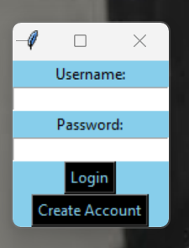
Figure7: Star panel
Test No:2
Purpose of the test: To register a new customer.
Expected result: After input all data and press button “Create Account” application connect with database and save there all data in customers ‘table.
Actual result: A new successfully customer registered.
Evidence of results
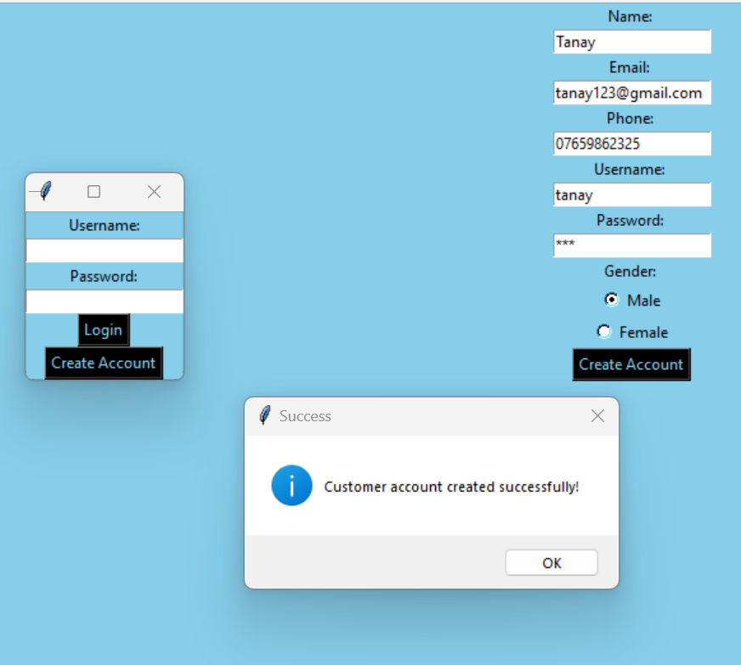
Figure8: Registration
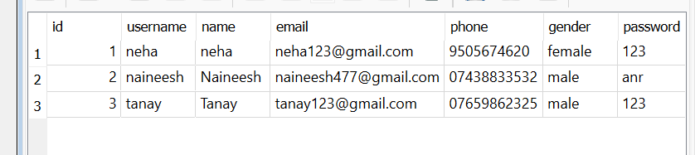
FIGURE9: Registration data stored in database

Test No:3
Purpose of the test: To verify the system's functionality, I attempted to register a new customer, ensuring the system prevents the registration process if the chosen username already exists in the database.
Expected result: The programme will prohibit a new user from registering with an existing username and will display an error message.
Actual result: The application shows the expected message.
Evidence of results
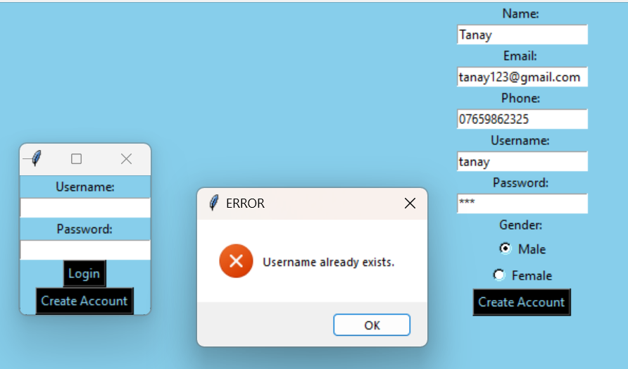
Figure10: Error message for username already exists.

Test No:4
Purpose of the test: To validate the application's functionality, I checked its performance during customer login, specifically testing its response to both valid and invalid usernames and passwords.
Expected result: After inputting matching data, the programme will display a success message and grant access to the menu panel. In the event of an incorrect login or password, it will display an error message.
Actual result: the application shows the expected message.
Evidence of results
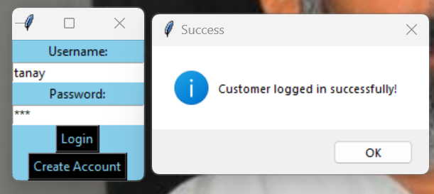
Figure11: Customer login with valid credentials
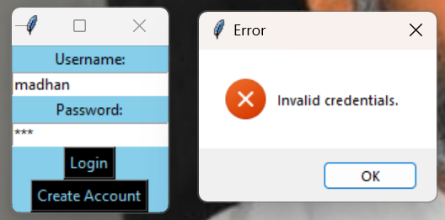
FIGURE:12: Showing error box because of invalid credentials
Test No:5
Purpose of the test: To validate the application's functionality, I tested whether a customer could successfully make a booking. Additionally, I verified if the database updated after inserting all the relevant booking data.
Expected result: After successfully booking a cab, the application shows a confirmation message, and the database securely retains all important data linked to the booking.
Actual result: The application displays a message verifying the successful completion of the booking procedure. The SQL database correctly stores all the input booking data.
Evidence of results
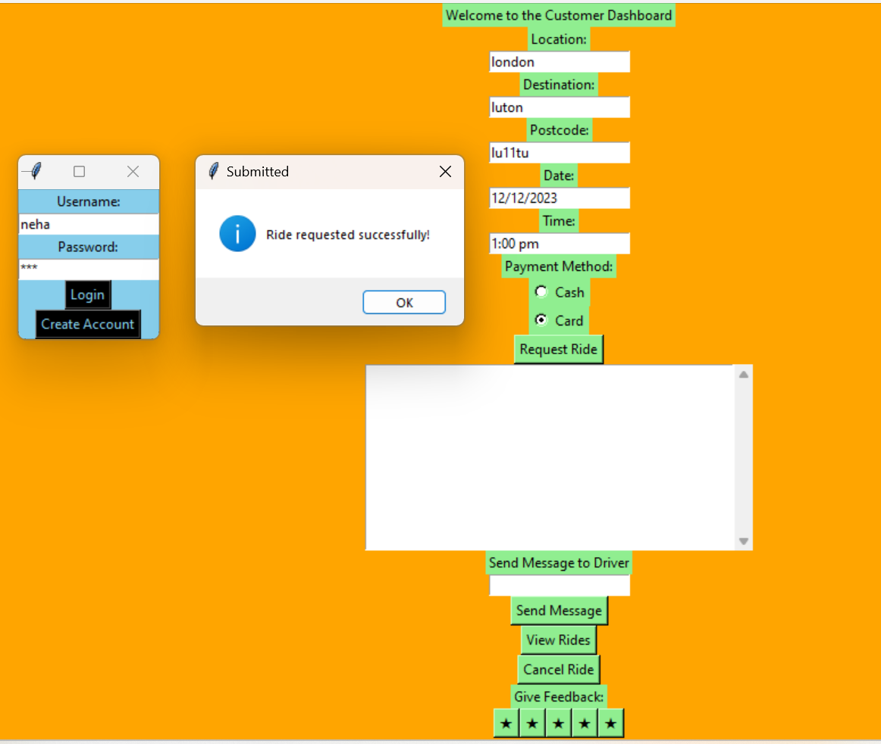
Figure13: Message box after successfully requesting the ride.
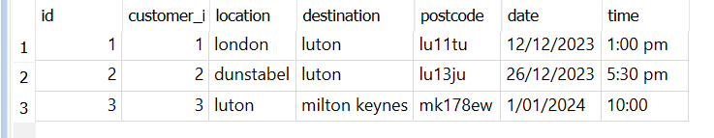
FIGURE14: showing the data saved after requesting for a ride.
Test No:6
Purpose of the test: To see if the application allows the customer to view his bookings after pressing the button.
Expected result: The application shows customer bookings.
Actual result: The application works as expected.
Evidence of results
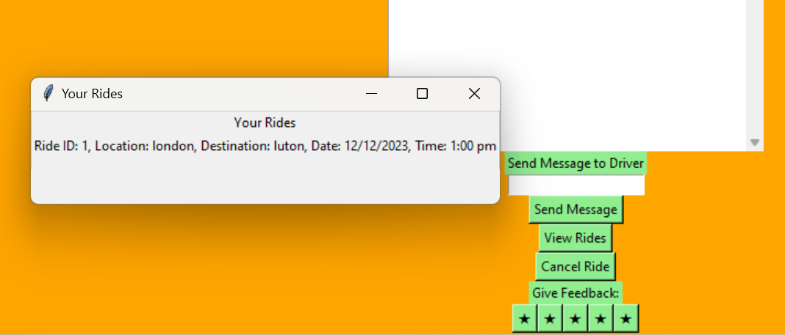
Figure15: After clicking on view ride button message box showing ride details.
And other features in the GUI (GRAPHICS USER INTERFACE):
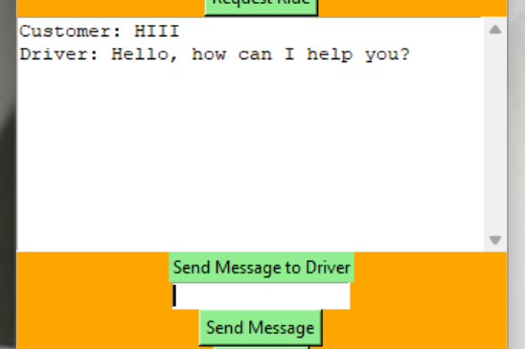
FIGURE16: Sending message to driver.
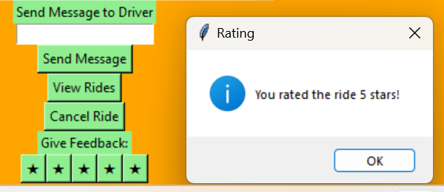
FIGURE16: giving feedback to driver.

Conclusion:
The completion of the taxi booking project is a big achievement in my programming career. This project includes a fully working system for managing client accounts, transportation requests, and an easy-to-use dashboard. The Graphical User Interface (GUI) provides users with an intuitive and visually appealing experience by presenting them with simple controls and input fields.
While the project provides the basic functionality as intended, there is always potential for improvement. Future versions may offer further features, such as:
- Real-time location tracking for drivers and consumers is included.
- Payment gateway implementation for online transactions.
- To increase service quality, a feedback mechanism for drivers must be implemented.
- Improvements to security and user authentication procedures.
Creating this project has been a fantastic learning experience that has allowed me to utilise and enhance my programming expertise tremendously. It has taught me a lot about database administration, GUI design, and system implementation.
In future initiatives, I intend to apply the knowledge learned from this experience to develop more advanced and efficient solutions. Furthermore, I want to devote adequate time to planning and development to assure greater quality and more complete functionality in future endeavours.
The taxi booking project was not simply a programming exercise but also a starting stone towards developing more inventive and useful software solutions.

APPENDIX:

import tkinter as tk
from tkinter import messagebox, scrolledtext
import sqlite3

root = tk.Tk()
root.title("Taxi Booking System")

create_account_window = None # Define create_account_window in the global scope
username_entry = None # Define global variables for entry fields
name_entry = None
email_entry = None
phone_entry = None
password_entry = None
gender_var = None # global variable

def login(username, password):
print("Username entered:", username) # Debugging line
print("Password entered:", password) # Debugging line

conn = sqlite3.connect('taxi_booking_system.db')
cursor = conn.cursor()

cursor.execute("SELECT username, password FROM customers WHERE username=? AND password=?", (username, password))
user = cursor.fetchone()

conn.close()

if user:
messagebox.showinfo("Success", "Customer logged in successfully!")
print("Logged in user:", username) # Debugging line
show_customer_dashboard(username)
else:
messagebox.showerror("Error", "Invalid credentials.")

def show_customer_dashboard(username):
global customer_dashboard_window, message_entry
# Get customer_id based on username
customer_id = get_logged_in_customer_id(username)

customer_dashboard_window = tk.Toplevel(root, bg="orange")
customer_dashboard_window.title("Customer Dashboar")

tk.Label(customer_dashboard_window, text="Welcome to the Customer Dashboard").pack()

tk.Label(customer_dashboard_window, text="Location:").pack()
location_entry = tk.Entry(customer_dashboard_window)
location_entry.pack()

tk.Label(customer_dashboard_window, text="Destination:").pack()
destination_entry = tk.Entry(customer_dashboard_window)
destination_entry.pack()

tk.Label(customer_dashboard_window, text="Postcode:").pack()
postcode_entry = tk.Entry(customer_dashboard_window)
postcode_entry.pack()

tk.Label(customer_dashboard_window, text="Date:").pack()
date_entry = tk.Entry(customer_dashboard_window)
date_entry.pack()

tk.Label(customer_dashboard_window, text="Time:").pack()
time_entry = tk.Entry(customer_dashboard_window)
time_entry.pack()

request_ride_button = tk.Button(customer_dashboard_window, text="Request Ride", command=lambda: request_ride(
location_entry.get(), destination_entry.get(), postcode_entry.get(), date_entry.get(), time_entry.get(), username))
request_ride_button.pack()
# Chat Box for Communication
chat_box = scrolledtext.ScrolledText(customer_dashboard_window, width=40, height=10)
chat_box.pack()

message_label = tk.Label(customer_dashboard_window, text="Send Message to Driver")
message_label.pack()

message_entry = tk.Entry(customer_dashboard_window)
message_entry.pack()

# Send Message Button
send_message_btn = tk.Button(customer_dashboard_window, text="Send Message", command=lambda: send_message(chat_box, message_entry.get()))
send_message_btn.pack()

view_rides_button = tk.Button(customer_dashboard_window, text="View Rides", command=lambda: view_rides(username))
view_rides_button.pack()

#cancel ride
cancel_ride_button = tk.Button(customer_dashboard_window, text="Cancel Ride", command=lambda: cancel_ride(ride_id))
cancel_ride_button.pack()

# Provide Feedback and Rating
feedback_label = tk.Label(customer_dashboard_window, text="Give Feedback:")
feedback_label.pack()

# Rating stars
rating_frame = tk.Frame(customer_dashboard_window)
rating_frame.pack()

# Create 5 stars as clickable buttons for rating
stars = []
for i in range(5):
star = tk.Button(rating_frame, text="\u2605", command=lambda i=i: rate_ride(i + 1))
star.grid(row=0, column=i)
stars.append(star)

ride_id = 1 # Placeholder for ride ID (replace with the actual ride ID)

def request_ride(location, destination, postcode, date, time, username):
conn = sqlite3.connect('taxi_booking_system.db')
cursor = conn.cursor()

# Get customer_id based on username
customer_id = get_logged_in_customer_id(username)

if customer_id:
try:
cursor.execute('''
INSERT INTO ride_requests (customer_id, location, destination, postcode, date, time)
VALUES (?, ?, ?, ?, ?, ?)
''', (customer_id, location, destination, postcode, date, time))
conn.commit()
conn.close()
messagebox.showinfo("Submitted", "Ride requested successfully! Details added to the database.")
except sqlite3.Error as e:
conn.rollback()
conn.close()
messagebox.showerror("Error", f"Failed to request ride: {e}")
else:
conn.close()
messagebox.showerror("Error", "Customer ID not found.")

def view_rides(username):
conn = sqlite3.connect('taxi_booking_system.db')
cursor = conn.cursor()

# Get customer_id based on username
customer_id = get_logged_in_customer_id(username)

if customer_id:
# Get rides based on customer_id from ride_requests table
cursor.execute("SELECT id, location, destination, date, time FROM ride_requests WHERE customer_id=?", (customer_id,))
rides = cursor.fetchall()

conn.close()

if rides:
rides_window = tk.Toplevel(root)
rides_window.title("Your Rides")

tk.Label(rides_window, text="Your Rides").pack()

# Display fetched rides
for ride in rides:
ride_info = f"Ride ID: {ride[0]}, Location: {ride[1]}, Destination: {ride[2]}, Date: {ride[3]}, Time: {ride[4]}"
tk.Label(rides_window, text=ride_info).pack()
else:
messagebox.showinfo("No Rides", "You have no previous or present rides.")
else:
conn.close()
messagebox.showerror("Error", "Customer ID not found.")

def get_logged_in_customer_id(username):
print("Username received by get_logged_in_customer_id:", username) # Debugging line

conn = sqlite3.connect('taxi_booking_system.db')
cursor = conn.cursor()

cursor.execute("SELECT id, username FROM customers")
all_customers = cursor.fetchall()

# Print all usernames present in the database
print("Usernames in the customers table:")
for customer in all_customers:
print(customer[1])

cursor.execute("SELECT id FROM customers WHERE username=?", (username,))
customer = cursor.fetchone()

conn.close()

if customer:
print("Customer ID found:", customer[0]) # Debugging line
return customer[0] # Returns the customer ID if found
else:
print("Customer ID not found") # Debugging line
return None # Return None if the username is not found

def get_username_from_customer_id(customer_id):
conn = sqlite3.connect('taxi_booking_system.db')
cursor = conn.cursor()

cursor.execute("SELECT username FROM customers WHERE id=?", (customer_id,))
result = cursor.fetchone()

conn.close()

if result:
username = result[0]
return username
else:
return None # Return None if the username is not found

def get_logged_in_username():
# Implement this function to retrieve the currently logged-in username
# You might use a global variable to keep track of the logged-in username
# or retrieve it from your authentication system
return "username" # Replace this with the actual username if available

def cancel_ride(ride_id):
conn = sqlite3.connect('taxi_booking_system.db')
cursor = conn.cursor()

try:
cursor.execute("DELETE FROM ride_requests WHERE id=?", (ride_id,))
conn.commit()
conn.close()
messagebox.showinfo("Cancelled", "Your ride has been cancelled.")
except sqlite3.Error as e:
conn.rollback()
conn.close()
messagebox.showerror("Error", f"Failed to cancel ride: {e}")

def rate_ride(rating):
messagebox.showinfo("Rating", f"You rated the ride {rating} stars!")

def send_message(chat_box, message):
chat_box.insert(tk.END, "Customer: " + message + "\n")
# Simulating a reply from the driver
chat_box.insert(tk.END, "Driver: Hello, how can I help you?\n")
# Clear message entry field
message_entry.delete(0, tk.END)

def save_account():
username = username_entry.get() if username_entry else ""
name = name_entry.get() if name_entry else ""
email = email_entry.get() if email_entry else ""
phone = phone_entry.get() if phone_entry else ""
gender = gender_var.get() if gender_var else ""
password = password_entry.get() if password_entry else ""

if username and name and email and phone and gender and password:
conn = sqlite3.connect('taxi_booking_system.db')
cursor = conn.cursor()

try:
cursor.execute('''
INSERT INTO customers (username, name, email, phone, gender, password) VALUES (?, ?, ?, ?, ?, ?)
''', (username, name, email, phone, gender, password))
conn.commit()
conn.close()
messagebox.showinfo("Success", "Customer account created successfully!")
create_account_window.destroy()
except sqlite3.IntegrityError:
conn.close()
messagebox.showerror("ERROR", "Username already exists.")
else:
messagebox.showerror("ERROR", "Please fill in all details.")

def show_create_account():
global create_account_window, username_entry, email_entry, phone_entry, password_entry
global name_entry, gender_var # Add the global variables you're using in the function

create_account_window = tk.Toplevel(root)
create_account_window.title("Create Customer Account")

tk.Label(create_account_window, text="Name: ").pack()
name_entry = tk.Entry(create_account_window)
name_entry.pack()

tk.Label(create_account_window, text="Email: ").pack()
email_entry = tk.Entry(create_account_window)
email_entry.pack()

tk.Label(create_account_window, text="Phone: ").pack()
phone_entry = tk.Entry(create_account_window)
phone_entry.pack()

tk.Label(create_account_window, text="Username: ").pack()
username_entry = tk.Entry(create_account_window) # Fix: Incorrect variable name here
username_entry.pack()

tk.Label(create_account_window, text="Password: ").pack()
password_entry = tk.Entry(create_account_window, show="*")
password_entry.pack()

tk.Label(create_account_window, text="Gender: ").pack()
gender_var = tk.StringVar()
gender_var.set("male") # Default gender selection
tk.Radiobutton(create_account_window, text="Male", variable=gender_var, value="male").pack()
tk.Radiobutton(create_account_window, text="Female", variable=gender_var, value="female").pack()

tk.Button(create_account_window, text="Create Account", command=save_account).pack()

def destroy_create_account_window():
global create_account_window
if create_account_window:
create_account_window.destroy()

# Login frame
login_frame = tk.Frame(root, bg="goldenrod1")
login_frame.pack()

tk.Label(login_frame, text="Username:").pack()
login_username_entry = tk.Entry(login_frame)
login_username_entry.pack()

tk.Label(login_frame, text="Password:").pack()
login_password_entry = tk.Entry(login_frame, show="*")
login_password_entry.pack()

login_button = tk.Button(login_frame, text="Login", command=lambda: login(login_username_entry.get(), login_password_entry.get()))
login_button.pack()
login_button.config(bg="lightblue", fg="black")

create_account_button = tk.Button(login_frame, text="Create Account", command=lambda: [destroy_create_account_window(), show_create_account()])
create_account_button.pack()
create_account_button.config(bg="lightblue", fg="black")

root.mainloop()

DATABASE CONECTION:
import sqlite3

conn = sqlite3.connect('taxi_booking_system.db')
cursor = conn.cursor()

cursor.execute('''
CREATE TABLE IF NOT EXISTS customers (
id INTEGER PRIMARY KEY AUTOINCREMENT,
username TEXT UNIQUE,
name TEXT,
email TEXT,
phone TEXT,
gender TEXT,
password TEXT
)
''')

cursor.execute('''
CREATE TABLE IF NOT EXISTS ride_requests (
id INTEGER PRIMARY KEY AUTOINCREMENT,
customer_id INTEGER,
location TEXT,
destination TEXT,
postcode TEXT,
date TEXT,
time TEXT,
FOREIGN KEY (customer_id) REFERENCES customers(id)
)
''')
conn.commit()

